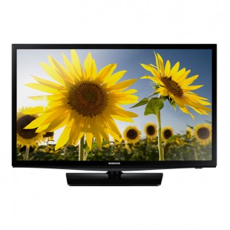

Samsung H4100

* HyperReal Engine
* Screen: 32" LCD
* DTS Studio Sound
* 1,366 X 768
* **Rs.34,999**